**Board Briefs**

**May 2024**

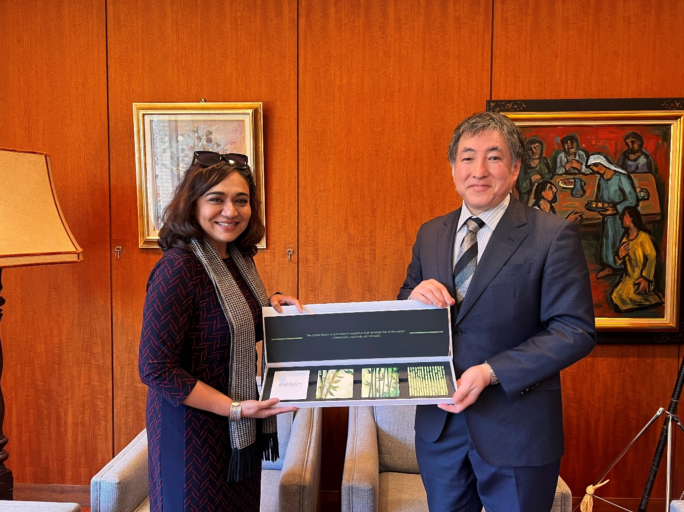

Dear Trustees,

I'm pleased to share some important updates with you since the last *Board Briefs* in March.

Firstly, I would like to report on my recent visits to higher education institutions and a foundation in the Philippines, Japan, and Bangladesh. These trips have been instrumental in strengthening our collaborations and deepening our understanding of these institutions. I was particularly impressed by their strong commitment to student learning, community engagement, and social action—values that resonate deeply with our mission to advance higher education in Asia.

Closer to home, we recently conducted a survey to gather your insights on our communication channels and meeting materials. Thank you for your valuable feedback. While the results reflect a high level of satisfaction, we have also pinpointed several areas for improvement. I invite you to review the results in the following pages and share any further comments or advice you may have.

Our ongoing staff development initiative is beginning to bear fruit. Through the creation of cross functional teams that are working together on specific projects, and individual coaching sessions, we are enhancing the skills and capabilities of our colleagues across all offices, including staff who are in mid-level to more senior roles. The overall feedback has been overwhelmingly positive. For a closer look, we have included reflections from Tommy and Jakarin on their leadership journeys.

In other news, Ricky recently delivered a well-received presentation on fundraising strategies to university leaders in Indonesia. His efforts are a vital part of our resource development strategy to foster a culture of giving within the Asian countries we serve.

Finally, I'm delighted to announce the addition of Mr. Christian Aung to our team as the new Education Technology Officer. Mr. Aung will be spearheading our efforts to integrate cutting-edge digital tools and platforms into our programming. We are also in the process of recruiting a Program Associate who will be responsible for establishing an alumni-serving function.

As always, I'm profoundly grateful for your continued support and guidance. I look forward to our upcoming Board meeting and study tour in Indonesia next month, where we can discuss in person all these matters and much more.

Pareena Gupta Lawrence

President, United Board

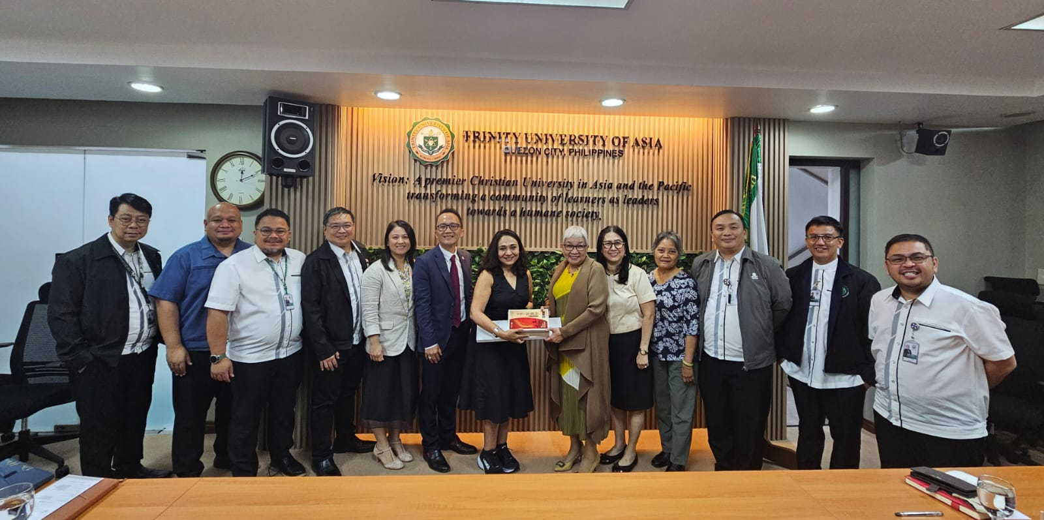

**Three Countries in Two Months**

In February, I visited the Philippines with Hope Antone, Jakarin Srimoon, and Rachel Zhang to deepen our partnerships and enhance our collaborations. On February 27th, at **Ateneo de Manila University** (AdMU), a long-standing collaborator and host of our leadership academy, we were warmly welcomed by President Fr. Roberto C. Yap, SJ, and his management team. We engaged with the dynamic teams at AdMU’s SALT Institute and Ateneo Teacher Center and enjoyed a tour of the scenic Loyola Heights campus, which gave us a glimpse into the vibrant student life at AdMU.

During our visit to **Trinity University of Asia**, President Gisela de Asas-Luna shared with us their best practices and how their leaders have implemented lessons learned from United Board programs that they have participated in. At **St. Scholastica’s College**, we explored initiatives in women's empowerment and their transition to co-education, and we were moved by the sisters' inspiring leadership stories. At **De La Salle University**, we were equally impressed by their strong programs, particularly those that relate to social entrepreneurship, among others.

We also enjoyed a delicious multi-course dinner that was hosted by Trustee Patricia Licuanan, at her home where she invited several key current and former leaders from universities in Manila.

In March, Ricky Cheng and Jakarin Srimoon accompanied me to Japan. On 11 March, we met President Tomoko Ueki and her team at **Doshisha University** in Kyoto. Our discussions focused on campus ministry and its role in supporting students’ mental well-being. The meeting was both productive and inspiring, setting the stage for further cooperation and partnership.

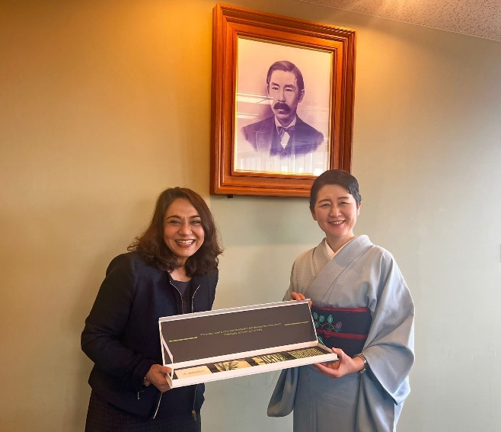

Later, we visited **Kwansei Gakuin University** in Osaka, where we met with Chancellor Motoo Nakamichi and other senior officers. Our discussions revolved around the challenges and opportunities for Christian higher education, as well as the United Board’s programs in faculty and leadership development. We reaffirmed our robust connections and explored potential avenues for future cooperation.

Continuing our travels From Osaka to Tokyo, we visited the **Wesley Foundation**, our partner in promoting women’s leadership in Asia, where we met with their Director/CEO Dr. Hikari Kokai Chang, exchanging ideas on promoting social entrepreneurship and community engagement.

Later that day, we were delighted to reunite with Dr. Anri Morimoto, former trustee and current president of **Tokyo Women’s Christian University** (TWCU). We learned about the unique challenges facing private Christian universities in Asia. We were pleased to hear about TWCU’s plans to expand their exchange partnerships with colleges and universities in India.

On 13 March, our journey took us to **International Christian University** (ICU) where we met with President Shoichiro Iwakiri and his management team. ICU has served as a longtime partner for us, hosting our Fellows and our Campus Ministries program. Our last stop in Japan was **Sophia University**, another valued partner that has hosted United Board Fellows. Discussions with Prof. Tetsuo Morishita, Vice President for Global Academic Affairs, centered on the sustainable development goals and the importance of nurturing global leaders.

From 18 to 20 March, Spurgeon and I travelled to Bangladesh to visit the **Asian University for Women** (AUW). Prof. Joanne Roberts, president of Yale-NUS College, joined us on this trip. Our engaging conversations with the Vice Chancellor, founder, officers, faculty, and students were most rewarding as we learned about the incredible mission of AUW and the students they serve from war-torn regions in Afghanistan, Gaza and Myanmar, to name a few. We also had an opportunity to tour their new campus, which is currently under construction.

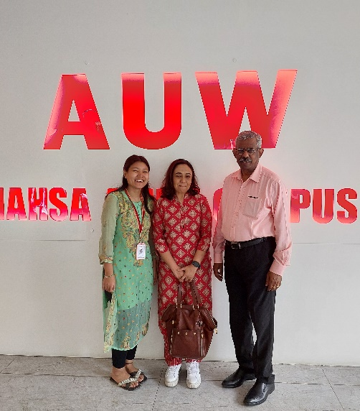

Overall, I can say that these visits provided valuable opportunities for in-depth discussions with the key leaders in higher education in Asia. As we revitalize our existing programs and develop new strategies, these interactions help reinforce our commitment to strengthening Christian higher education in these regions. I also reassured our partners that the United Board will continue to be their steadfast partner, an ally in exploring new opportunities and collectively overcoming the challenges we face in higher education.

**Trustees Survey on Communication Channels and Meeting Materials**

A survey to assess communication channels and meeting materials was distributed to the Trustees on February 29. By mid-March, 12 Trustees (80%) had responded. The survey consisted of 10 questions designed to gather Trustees' opinions on existing communication methods, as well as the frequency and content of committee meetings and general Board meeting materials.

From the survey results, the vast majority of Trustees rely on the Trustees Updates (now *Board Briefs*) for information about the United Board. For social media, about half of them use LinkedIn and Facebook.

In terms of the frequency and adequacy of information across different channels like *Horizons* and our website, 83.3% of Trustees find the current approach appropriate. This sentiment is mirrored in their views on the frequency and adequacy of information provided for committee meetings.

Regarding the volume of Board materials, while 75% of respondents feel the amount is appropriate, 25% believe it is excessive and challenging to review and digest. When asked about their preferences for these materials, a significant portion (41.7%) expressed a desire for “more concise content” that focuses on “key information”.

Trustees also provided feedback that can be divided into categories such as general communication, committee/Board meetings, and Board interaction.

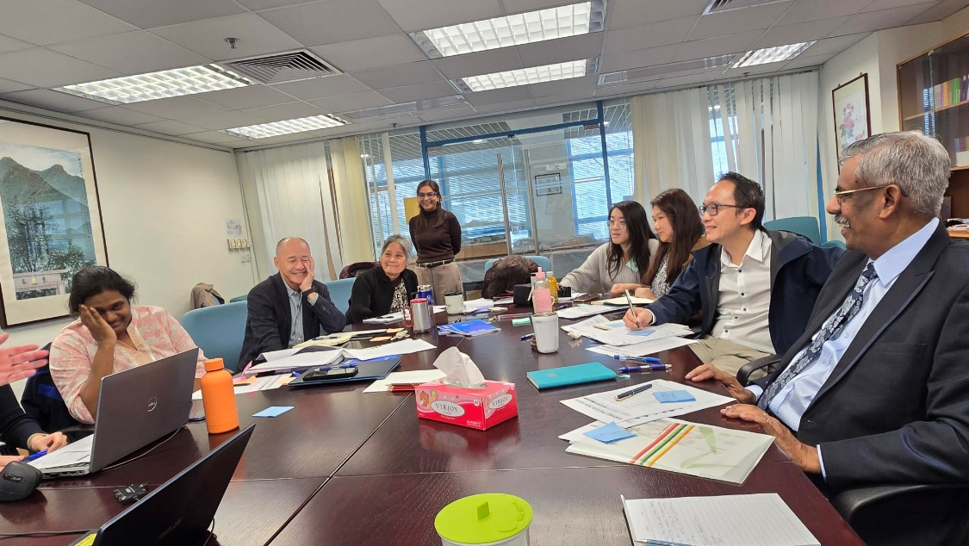

**Staff Development**

**Reflections from Two Senior Staff Members**

“If life is a path that forks and bifurcates at different points, where one closes a gate and goes down one tributary, then one takeaway from the staff development exercise led by Open Consulting, is the realization that it is always possible to retrace steps, reopen closed gates, and find paths to discover new landscapes and reach new frontiers. The tools provided by the consultants, include recognizing “downloading” (putting aside received ideas to make space for new ones), empathy walks, and stakeholder interviews (emotional engagements with co-workers). “Unhinging gates” and going down unexplored paths are not only meaningful and productive, but, when taken together by different people pursuing common goals, also build a shared identity and unlock and supplement the potential of all involved.”

“As the exercise is still ongoing, I’m very much curious to see what it would do to the esprit de corps of the teams in six months, in a year, and beyond.” **(*Tommy Cho, Director of Communications)***

"Participating in staff development programs has been instrumental in fostering connections with colleagues and gaining insights into our collective challenges. These interactions have spurred personal growth and a deeper understanding of our joint experiences. Through sharing sessions, I have realized how my past experiences have shaped my ability to collaborate, ultimately this recognition has strengthened my relationships with my colleagues and enhanced our collective unity.

“Working together on our Team project on Vision and Mission has strengthened these connections by promoting open dialogue, idea sharing, active listening, and teamwork among the senior management team.

“In conclusion, the staff development initiatives have encouraged personal and professional growth, bridging divides, and nurturing camaraderie. These experiences have invigorated our commitment to the organization's values and purpose, empowering us to better serve our mission and contribute to the advancement of Christian higher education in Asia.” **(*Jakarin Srimoon, Director of Leadership Development)***

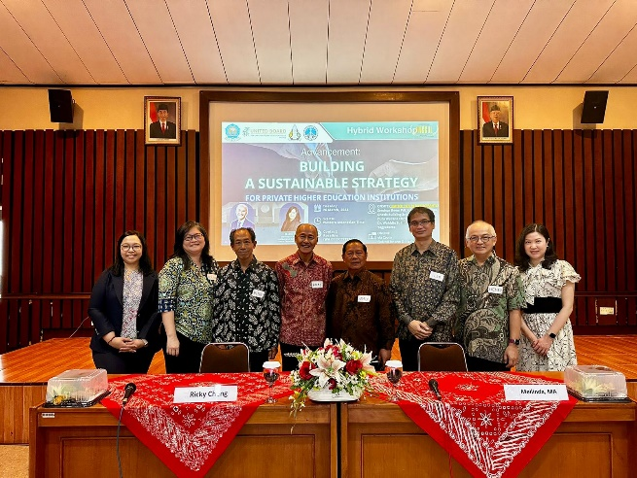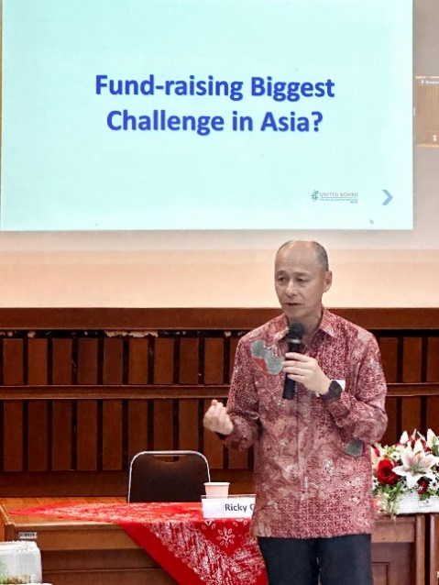

**Advocating for a Culture of Giving in Indonesia**

On 26 March, Ricky Cheng conducted a workshop titled “Building a Sustainable Strategy for Private Higher Education Institutions” at Duta Wacana Christian University in Yogyakarta, Indonesia. The workshop drew 50 senior leaders from the region, including many who traveled long distances. Ms. Raynesta M. Indri Malo, head of the advancement office at Unkriswina Sumba, flew in from the small island of Sumba via Bali. She expressed her gratitude for the knowledge and practical ideas shared by Ricky, and for the encouragement to "start something, even if it is a small step for advancement."

The Rev. Mesach Daniel Beeh, founder and general chairman of the Foundation of Artha Wacana Christian University, commented, “I do appreciate this workshop that strengthens our unity and willingness to pool and share our resources as Christian higher education institutions.” Mrs. Dewi Kumalasari, S. Si., head of the Protocol Unit of Krida Wacana Christian University, agreed: “I have learned that we have to find out the uniqueness of our institutions and use it as our advantage in working together with related units for the betterment of the university. I also realized that we need to dream big and persevere in order to achieve our mission.”

**Staffing Updates**

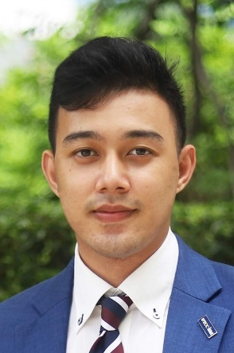

We are pleased to announce that Mr. Christian Aung will soon be joining the United Board as our new Education Technology Officer. In this role, Christian will develop and execute a plan for integrating AI and other advanced Educational Technologies (EdTech) into our programming initiatives as well as our internal office functioning. His efforts will align closely with our key priorities. Christian will collaborate extensively with team members, network institutions, and grantees to ensure the successful implementation of EdTech programs. He will also facilitate faculty development in AI and hybrid learning and promote lifelong learning opportunities.

Christian brings a wealth of experience to this position, having previously served as Head of Marketing at German Standard and as an Academic Coordinator at Harbour.Space University of the Thai Chamber of Commerce, where he also led ASEAN Programs. He holds an MBA in Digital Marketing from Harbour.Space and an MBA in Entrepreneurship from the University of the Thai Chamber of Commerce, where he also holds his BBA in International Business Management.

**Schedule for Board Meeting and Study Tour in Yogyakarta, Indonesia in June**

**Ava, need your help on this part!**